|  |  |  |  |
| --- | --- | --- | --- |
|  | **Faculty of Engineering & Technology** | | |
|  | **Ramaiah University of Applied Sciences** | | |
| **Department** | Computer Science and **Programme** B. Tech. Computer Science and  Engineering Engineering | | |
| **Semester/Batch** | 5th/2018 | | |
| **Course Code** | 19CSC302A | **Course Title** | Database Systems |
| **Course Leader(s)** | A. Prabhakar, Gp Capt N Rath VSM, Ami Rai E. | | |

|  |  |  |  |  |  |  |  |  |
| --- | --- | --- | --- | --- | --- | --- | --- | --- |
| **Assignment - 01** | | | | |  | |  |  |
| Register No. | | | **18ETCS002100** | Name of Student |  | ROHITH N |  |  |
| **Sections** |  | **Marking Scheme** | | | **Max Marks** | | **First Examiner**  **Marks** | **Second Examiner**  **M**  **arks** |
| **Part**  **A** | A.1 | Merits and demerits of relational and graph databases | | | 02 | |  |  |
| A.2 | Justification of the stance taken and conclusion | | | 03 | |  |  |
|  | **Part-A Max Marks** | | | **05** | |  |  |
| **Part B**  **1** | B1.1 | List of functional and data requirements | | | 03 | |  |  |
| B1.2 | Discussion on the entities, attributes, and relationships | | | 02 | |  |  |
| B1.3 | ER diagram | | | 02 | |  |  |
| B1.4 | Identification of any requirement that is not possible to model using ER diagram | | | 03 | |  |  |
|  | **B1 Max Marks** | | | **10** | |  |  |
| **Part B**  **2** | B2.1 | Design of database schema | | | 03 | |  |  |
| B2.2 | Discussion on the constraints | | | 02 | |  |  |
| B2.3 | Implementation using SQL commands | | | 02 | |  |  |
| B2.4 | Update operations violating the schema constraints | | | 03 | |  |  |
|  | **B2 Max Marks** | | | **10** | |  |  |
|  | **Total Assignment Marks** | | | | **25** | |  |  |

|  |  |  |  |  |
| --- | --- | --- | --- | --- |
| **Course Marks Tabulation** | | | | |
| **Component-**  **1(B)Assignment** | **First**  **Examiner** | **Remarks** | **Second Examiner** | **Remarks** |
| A |  |  |  |  |
| **Marks (out of 10)** |  |  |  |  |
| Signature of First Examiner Signature of Second Examiner | | | | |

Q A.1 Merits and demerits of relational and graph databases

* Merits of relational database:
* Data integrity : Data integrity is an essential feature of the relational model. Strong data typing and validity checks ensure data fall within acceptable ranges, and required data are present. Referential integrity among tables prevents records from becoming incomplete or orphaned. Data integrity helps to ensure accuracy and consistency of the data.
* Precision: The usage of relational algebra and relational calculus in the manipulation of the relations between the tables ensures that there is no ambiguity, which may otherwise arise in establishing the linkages in a complicated network type database
* Data Independence: Data independence is achieved more easily with normalization structure used in a relational database than in the more complicated tree or network structure.
* Data Manipulation Language: The possibility of responding to query by means of a language based on relational algebra and relational calculus.
* Demerits of relational database:
* Software is expensive
* Complex software means expensive hardware
* Requires skilled knowledge to implement
* Certain applications are slower processing
* More difficult to recover if data is lost
* Merits of graph database:
* When there are relationships that you want to analyse Graph databases become a very nice fit because of the data structure
* Graph databases are very fast for associative data sets Like social networks
* Map more directly to object oriented applications
* Clear and manageable representation of relationships
* Flexible and agile structures
* Demerits of graph database:
* If data is just tabular with not much relationship between the data, graph databases do not fare well
* Difficult to scale, as designed as one-tier architecture.
* No uniform query language

Q A.2 Justification of the stance taken and conclusion

* Graph databases can replace the relational databases:
* Relational database is having tables with lots of columns and a few of these columns are used by rows. Data can have lots of very different attributes and only a few of them can be meaningful for some data items. In contrast to relational database, graph database, stores only meaningful attributes for the related node and adding data for only used attributes for the related node increase efficiency
* Relational databases are more mature and secure as compared to graph databases, but its schema is fixed, which makes it difficult to extend these databases and less suitable to manage schemas that evolve over time.
* The another criteria is that relational database require a predefined schema before adding any data to the system while graph database provide adding data to the system without needing any predefined schema
* The graph databases retrieve the results of the set of predefines query faster than relation databases.
* Graph database is a very powerful tool to annotate resource and create data models for the repositories of the different types of resources.
* conclusion
* In the phase of deciding which database model is most suitable for specific domain, data should be investigated by considering basic criteria .if data has lots of many-to-many relationships, using graph model can be very efficient .graph database traverse data very efficiently by using relationship entities while relational database traverse database has to use many complex and expensive join operations.

Q B1.1

* Functional and data requirements for online furniture shopping system:
* Data requirements:
* Personal information:

Data required for the user to register such as name ,phone number , address etc..

* Availability of stock:

Checking stock is available or not

* Delivery:

Information required by the company to deliver the product to the customers doorstep.

* Functional requirement
* The application should allow to customer logins by entering the valid username and password.
* The application should allow to customer to search and select the product by categories (ex: chairs).
* The application should allow to customer to buy the product directly or add products to the cart, then buy the product.
* The application should allow to admin to manage the product (means update the products) and categories of products.
* The application should allow to admin to view the customer activity and details of customer.
* The application should allow to, if customer wants to buy or add the product to cart, then he/she must be registered and login, user can’t go to the shopping without registration and login.
* The application should allow to admin to logout.
* The application should allow to customer to logout.

Q B1.2

* **Entity**: a thing with distinct and independent existence.
* **Attribute**s: these are properties of entity.
* **Relationship**: the number of occurrences in one entity that is associated with the number of occurrences in another entity
* Entities in online furniture shopping system:

i. Customer

ii. Admin

iii. Product

iv. cart

v. Categories

* attributes in online furniture shopping system:
* Name, address, contact_no, login_id and password for customer entity.
* Ad_login_id and Ad_password for admin entity.
* Ca_id and ca_name for categories entity.
* Product_name, product_id, price, colour for product entity.
* Quantity,Product_id,login_id for cart entity.
* Relationship between the entities in online furniture shopping system:
* Customer to cart is 1-1 Relationship (relationship name is fills).
* Product to categories N-1 Relationship (relationship name is has).
* Customer to categories N-N Relationship (relationship name is select).
* Customer to product is N-N Relationship (relationship name is buys).
* Customer to admin is N-N Relationship (relationship name is viewed_by).
* Admin to categories N-N Relationship (relationship name is manages).
* Admin to products N-N Relationship (relationship name is manages).

Q B1.3

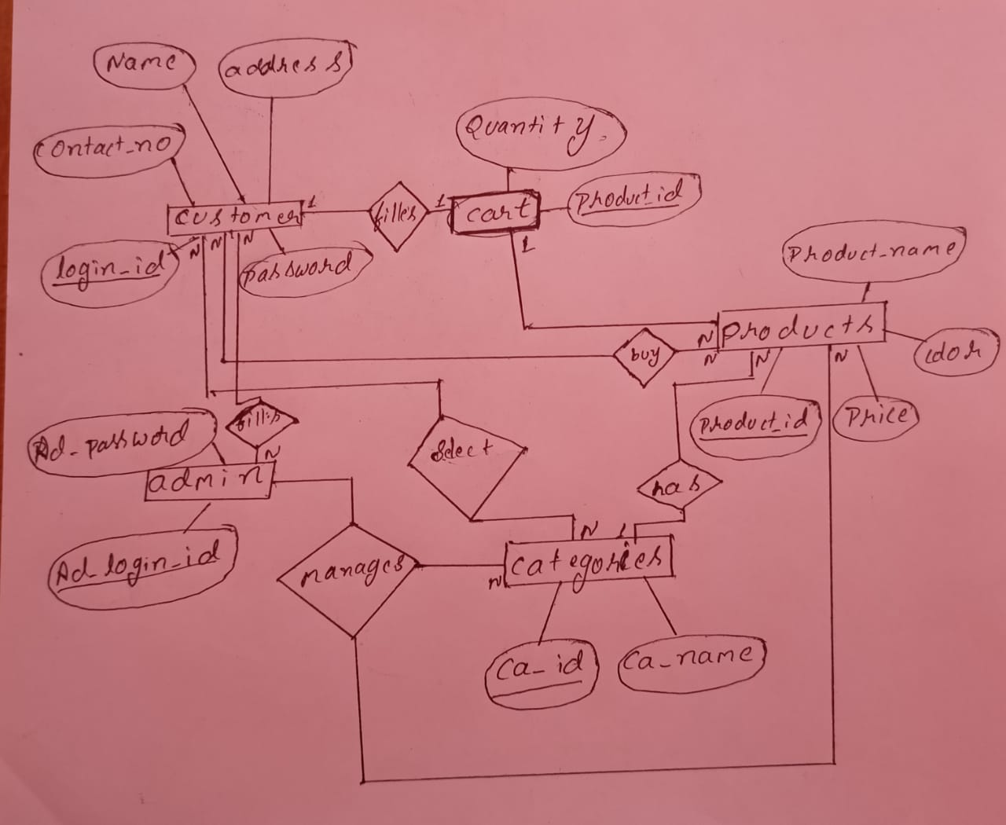

Q B1.4

* Identified problem is the application will not show if the product is out of stock it will not show it will show an error hence it can be resolved using the conceptual data model,since data model is a model focuses on identifying the data used in the business but not its processing flow or physical characteristics this problem can be rectified.

**QB 2**

**B2.1**

customer

|  |  |  |  |  |
| --- | --- | --- | --- | --- |
| NAME | address | Contact_no | Login_id | password |

Admin

|  |  |
| --- | --- |
| Ad_login_id | Ad_password |

product

|  |  |  |  |
| --- | --- | --- | --- |
| Price | Product_name | Product_id | color |

Cart

|  |  |
| --- | --- |
| Quantity | Product_id |

Categories

|  |  |
| --- | --- |
| Ca_id | Ca_name |

**B2.2**

Constraints are the rules enforced on the data columns of a table.

* Constraints applicable for the developed schema are:

1. Key constraints:

1. Primary key constraints: it is uniquely identifies each record in a table.

* Examples of primary key used in developed schema: login_id, Ad_password, ca_id, product_id,

2. Foreign key constraints: Foreign keys are the columns of a table that points to the primary key of another table.

* Example of foreign key used in developed schema Ad_password, ca_id etc.

1. Not null: NOT NULL constraint makes sure that a column does not hold NULL value.

* Example of not null used in developed schema: name, address

1. Unique: unique constraint enforces a column or set of columns to have unique values.

* Example of unique used in developed schema: A_password,

**B2.3**

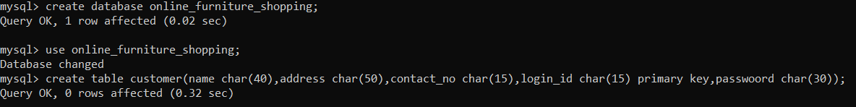

Above figure shows online furniture shopping database and creating table for customer

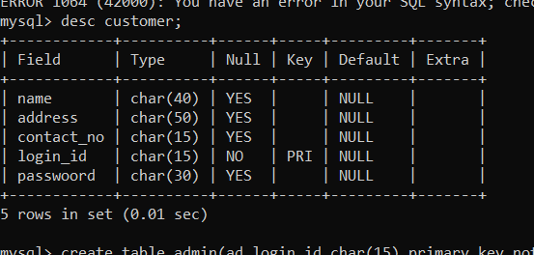

Above figure shows customer database

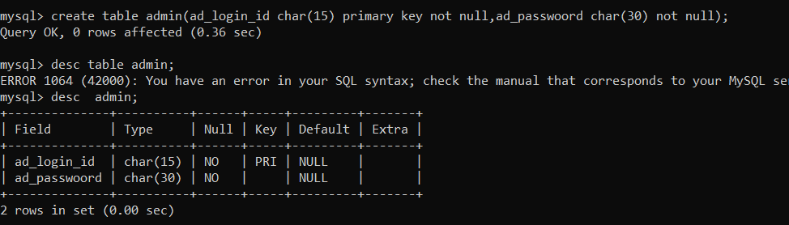

Above figure shows admin database

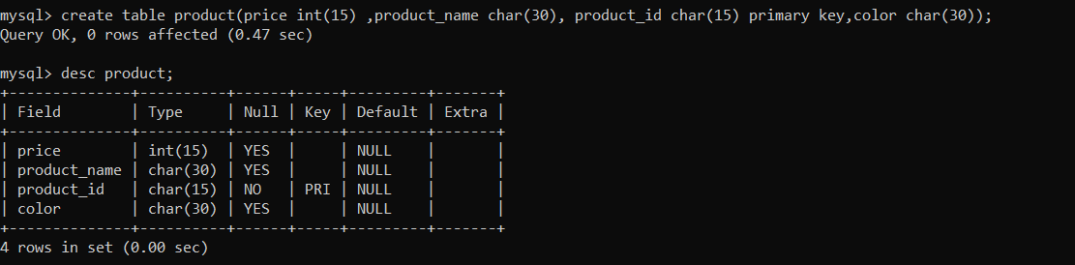

Above figure shows product database

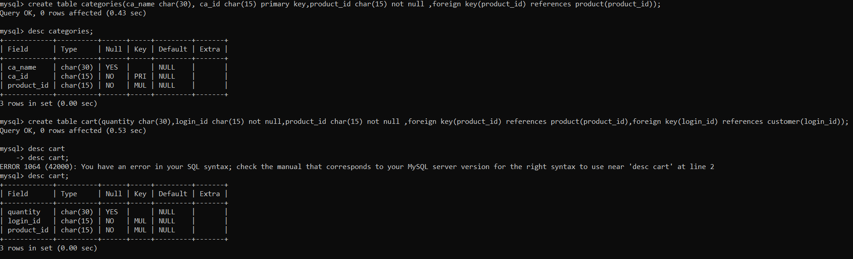

Above figure shows categories and cart database

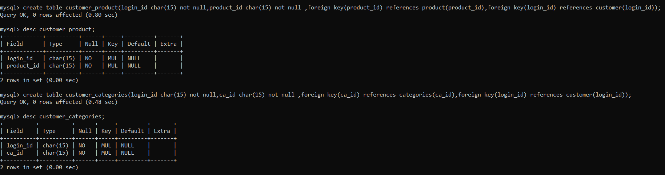

Above figure shows customer_product and customer_categories database

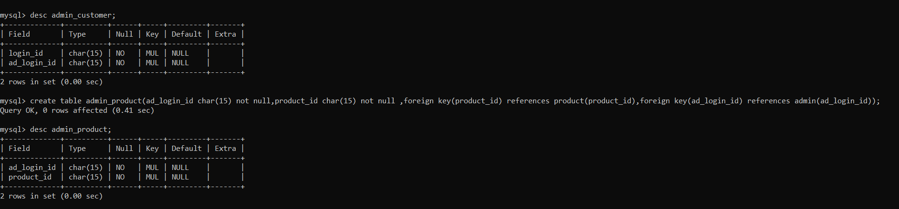

Above figure shows admin_product and admin_customers database

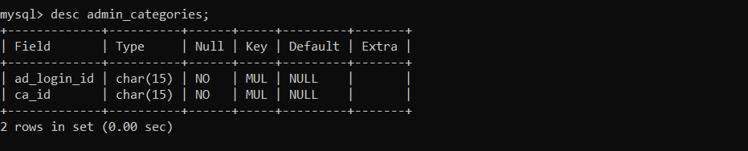

Above figure shows admin categories database

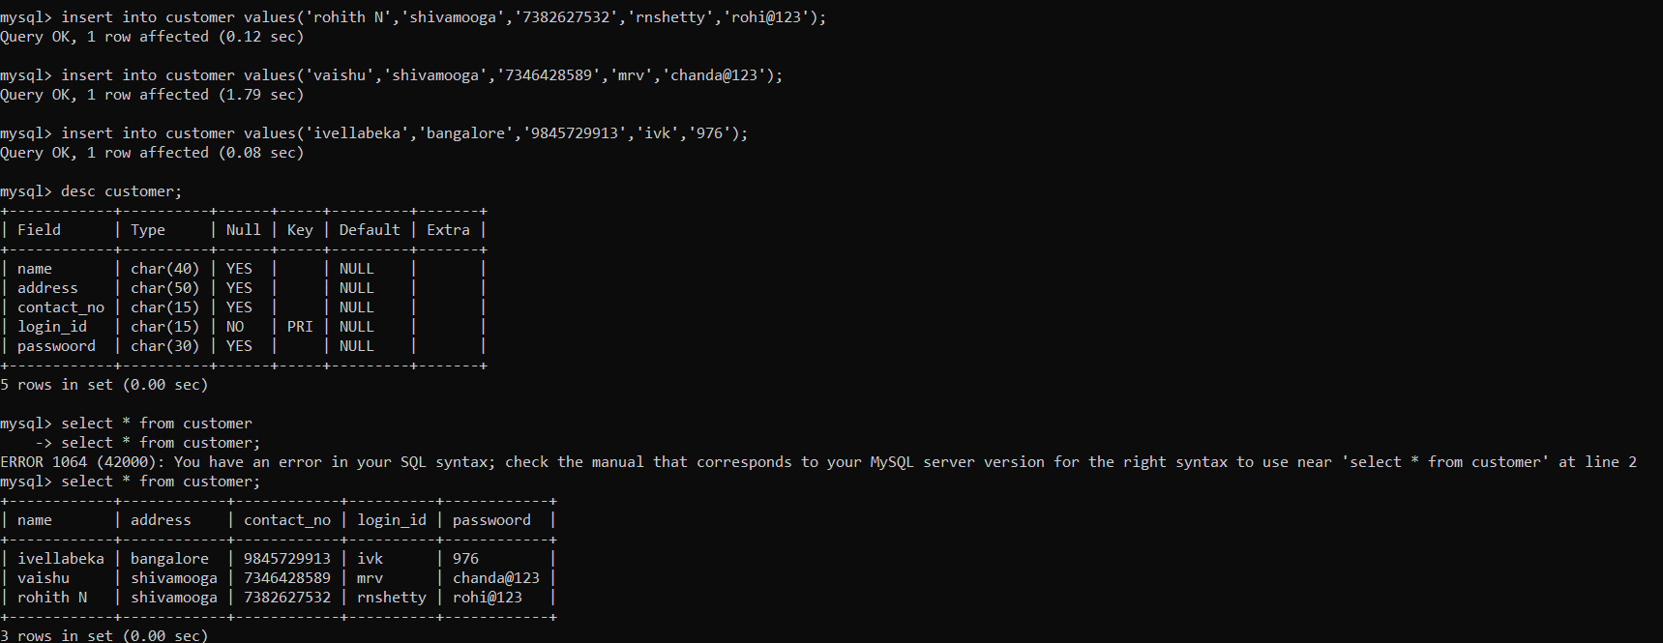

Above figure shows inserting values to customer database

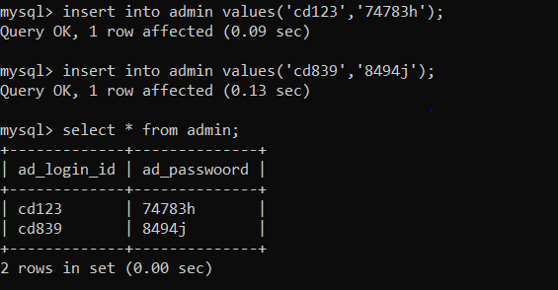

Above figure shows inserting values to admin database

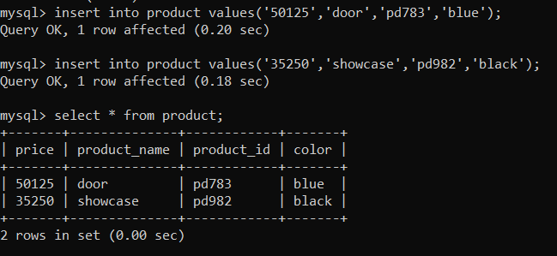

Above figure shows inserting values to product database

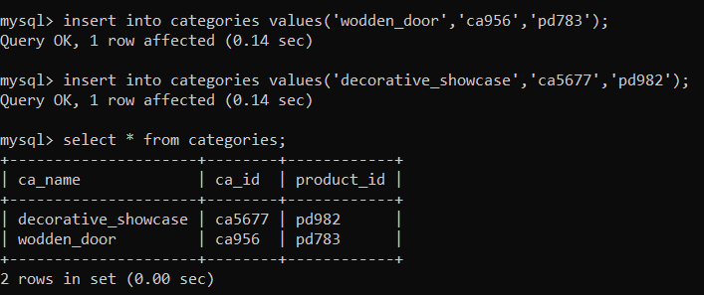

Above figure shows inserting values to categories database

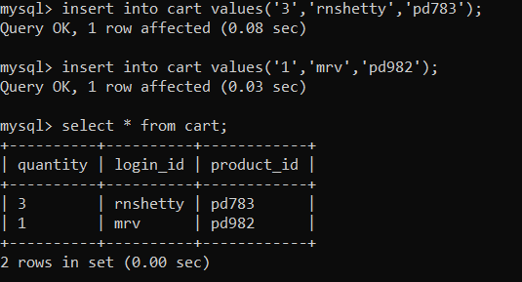

Above figure shows inserting values to cart database

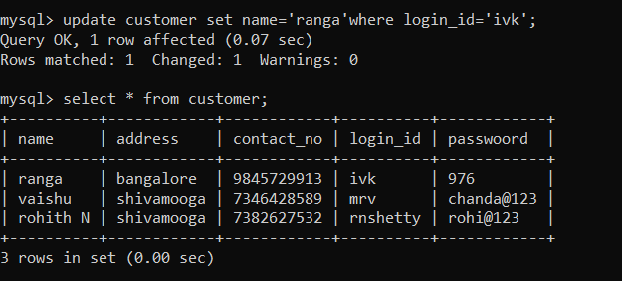

Updating customer name in customer database

**B2.4**

While updating it shows the error

